
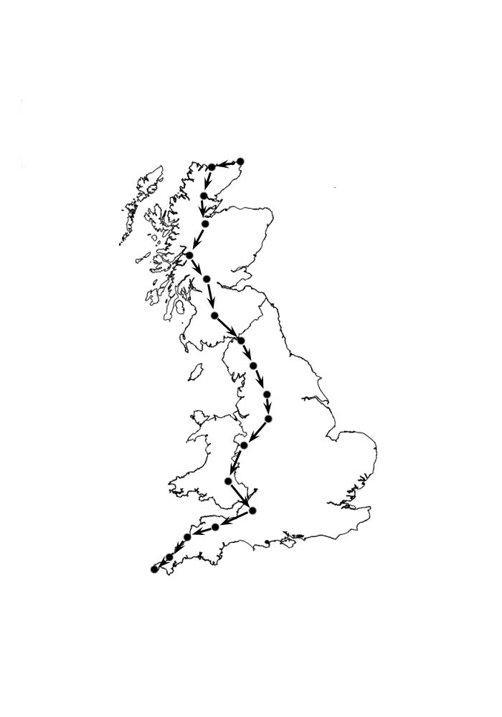
PRESS RELEASE:

Father and son team
up for End to End ride.

Graham and Ben Brodie from
Newton Abbot in Devon will
be teaming up to ride from
John ‘o Groats to Lands End
in August 2004.
The ride will take 19 days, with 2 rest days planned, and an average of 50 miles per day.
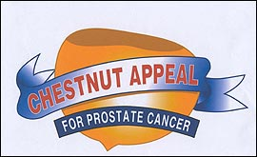
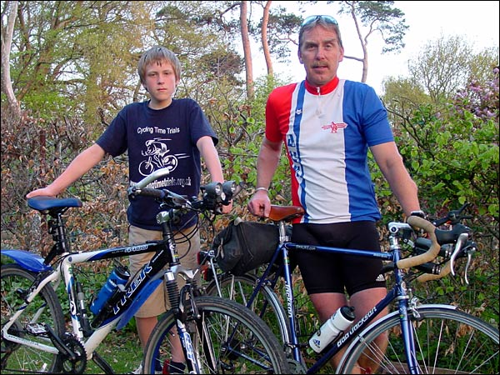
It will be a big challenge for Ben, aged 13 who is a pupil
at Knowles Hill school in Newton Abbot. He has already done two 100Km Audax events as part of his training, and he regularly rides with the Torbay CTC group.
Two charities will benefit from the run, the local Chestnut Appeal for Prostate Cancer, and the Worldwide charity Amnesty International.
Further details: 07980-241245 or 01626-367977

